IRAS ID 232385
Optimising psychological treatment for Anxiety DisordErs in Pregnancy: a feasibility treatment trial (ADEPT)
We would like to invite you to take part in our research study. Before you decide we would like you to understand why the research is being done and what it would involve for you. Please take time to read the following information and discuss it with others if you wish. Ask us if there is anything that is not clear or if you would like any more information. Part one tells you about the purpose of this study and what will happen if you take part. Part two gives you more detailed information about the conduct of the study. Thank you for reading this.
PART ONE
What is the purpose of the study?
Anxiety disorders (including Post-traumatic stress disorder (PTSD), obsessive-compulsive disorder (OCD), social anxiety disorder and panic disorder), affect approximately 11% of pregnant women. Cognitive behaviour therapy (CBT), a well-known talking therapy, is known to be an effective treatment for anxiety disorders and this is routinely offered to pregnant women with anxiety disorders. CBT involves understanding the thoughts, feelings and behaviours involved in particular disorders and using a range of techniques to change them.
Recently, studies have demonstrated that the same CBT treatment delivered in a shorter space of time, over fewer but longer sessions in a few weeks, can be as helpful, meaning people can get better more quickly. However, this format has not been explored for women who are currently pregnant.
This research aims to investigate whether pregnant women with anxiety disorders find the format of time intensive CBT (IN-CBT) helpful and if it is possible to test it against the current standard format, weekly CBT.
Why have I been invited?
You have been invited to take part in this study because you are 12-20 weeks pregnant and may have an anxiety disorder that is suitable for treatment with CBT: one of either obsessive-compulsive disorder, post-traumatic stress disorder, social anxiety disorder or panic disorder.
Do I have to take part?
No. It is up to you to decide whether or not to take part. If you decide to take part, you will be given a copy of this information sheet to keep and be asked to sign a consent form. If you decide to take part, you are free to withdraw at any time and without giving a reason. If you decide not to take part or the study is not suitable for you, you will, unless you do not want to, be referred to routine care in psychological therapy services (IAPT) for assessment.

What will happen to me if I take part?
There are three parts to this study, which are explained below.
- Initial Screening: If you would like to take part in this study, we will first ask you to complete a short interview to see if the study is suitable for you which will check the inclusion criteria for the study.

- Therapy: If you decide to take part you will be asked to sign the study consent form. You will be registered with your local primary care psychological therapy (IAPT) service as a patient and will be asked to complete standard questionnaires for this service as well as a short additional questionnaire.

After this initial assessment you will then be randomised to either (i) standard CBT of one hour/week for 10 weeks or (ii) intensive CBT in which 10 hours of treatment will be arranged over a 1-2 week period. The treatment in either arm will start as soon as is possible (within the recommended 2 week window for pregnant women). Both treatments are one to one with a qualified therapist. Both groups will receive a follow up CBT session with their therapist towards the end of pregnancy and one in the early postnatal period.

- Final assessment: You will be asked to complete a final research assessment with a researcher visiting you at home or meeting at another location if you prefer, when your baby is 3 months old. At this assessment we would like to make a short video of you playing with your baby, conduct an interview concerning your experiences of treatment and taking part in the study. We would also like you to complete some questionnaires.
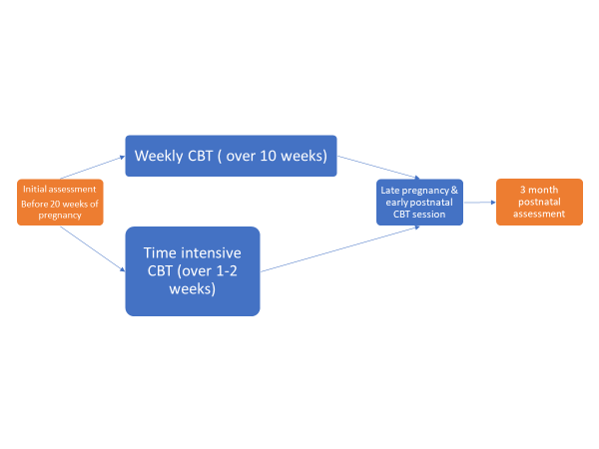

You will receive £10 after the initial and last assessment as thanks for your participation in the study (£20 in total).

The final interview will seek your detailed feedback on the experience of therapy. The mother-child video aims to give another perspective on how helpful the therapy has been.

As is standard practice, your therapist will ask you to record your CBT sessions in order to get the most out of treatment. They will also ask your permission to audio or video record the sessions. We will select some of these sessions to audit to assess the therapists.

As in routine care, if it is the case that the problem significantly worsens or other significant issues arise that require more input, your therapist will discuss with you the options for referral to local specialist perinatal mental health services.
What are the possible disadvantages and risks of taking part?
The treatment on offer is already widely used with pregnant women with anxiety disorders. It is a talking therapy and, whilst this may not work for everyone, it is considered a low risk intervention. You will not be able to choose which format you receive in this study and may be allocated to a type of the treatment that you did not prefer. There are some additional questionnaires to complete for this research which will take additional time.
What are the possible benefits of taking part?
CBT is a well-established effective treatment in both standard and time-intensive forms. We hope all women taking part will gain some benefit from the treatment in terms of help with their anxiety. By taking part in the study you will have an opportunity to make a contribution to our scientific understanding of how best to treat pregnant women with anxiety disorders.
Will my taking part be kept confidential?
Yes. We will follow ethical and legal practice and all information about you will be handled in confidence. The details are included in part 2.
This completes Part one. If the information in Part one has interested you and you are considering taking part, please read additional information in Part two before making a decision.
PART TWO
What will happen if I don’t want to carry on with the study?
Even if you agree to take part, you are free withdraw from the study at any point, without giving us a reason. If you do decide to withdraw from the study, we may still use some of the data that you have already provided us, but this will be anonymised and will not be linked to any of your personal details (e.g. name, address etc.).
What if there is a problem?
If you wish to complain about any aspect of the way in which you have been approached or treated during the course of this study, you should contact the research team in the first instance or SLaM Patient Advice and Liaison Service (PALS): pals@slam.nhs.uk
The University has arrangements in place to provide compensation for any harm arising from participation in the Study, and for which the University is legally liable as the Sponsor.
Will my taking part in the study be kept confidential?
All information that is collected about you during the course of the research would be kept strictly confidential and would be accessible only to the research team. Responsible members of King’s College London may be given access to data for monitoring and/or audit of the study to ensure that we are complying with regulations and that the study is being ethically run and is not harmful.
Any information about you would be assigned a code and will not have your name on it. We are obliged to keep all research data for 7 years.
The only circumstances in which confidentiality would be breached would be in the rare situation in which it was judged that you or someone else was at risk of serious harm or if a court applied for the information. In these circumstances we would endeavour to discuss the matter with you and would disclose only information of immediate relevance.
We will inform your GP that you are taking part in the study unless you decide you would not like this to happen.
How will my personal data be used and what are my rights?

South London & Maudsley NHS Trust will use your name and contact details to contact you about the research study, and make sure that relevant information about the study is recorded for your care, and to oversee the quality of the study. Individuals from King’s College London and regulatory organisations may look at your medical and research records to check the accuracy of the research study. South London & Maudsley NHS Trust will pass these details to King’s College London along with the information collected from you and/or your medical records. The only people in King’s College London who will have access to information that identifies you will be people who need to contact you to arrange a research visit or audit the data collection process. The people who analyse the information will not be able to identify you and will not be able to find out your name or contact details.

Your video and audio data will only be identified by a participant number, will be password protected and kept on secure computers.

King’s College London is the sponsor for this study based in the United Kingdom. We will be using information from you in order to undertake this study and will act as the data controller for this study. This means that we are responsible for looking after your information and using it properly. King’s College London will keep identifiable information about you from this study for 7 years after the study has finished.

Your rights to access, change or move your information are limited, as we need to manage your information in specific ways in order for the research to be reliable and accurate. If you withdraw from the study, we will keep the information about you that we have already obtained. To safeguard your rights, we will use the minimum personally-identifiable information possible.
You can find out more about how we use your information by contacting the Chief Investigator, Fiona.challacombe@kcl.ac.uk or visiting the KCL website: https://www.kcl.ac.uk/research/support/research-ethics/kings-college-london-statement-on-use-of-personal-data-in-research.aspx.
What will happen to the results of the study?
We may publish the results of this study in a scientific journal. Any research publication would not identify you individually. Publications may include individual quotes from the interview but any identifiable information will be removed. If you wish to obtain a copy of the published results, please inform the researcher. We would be delighted to send them to you when they are available.
Who is organising and funding the research?
The research is organised by King’s College London, South London & Maudsley NHS Trust and funded by the National Institute of Health Research.
Who has reviewed the study?
This research has received ethical approval from the XXXX Research Ethics Committee (Reference: )
Further information and contact details
If you have any further questions about this particular study, please contact Fiona.challacombe@kcl.ac.uk, 0203 2283696
Thank you for taking the time to read this information sheet and considering whether to take part in this research.

